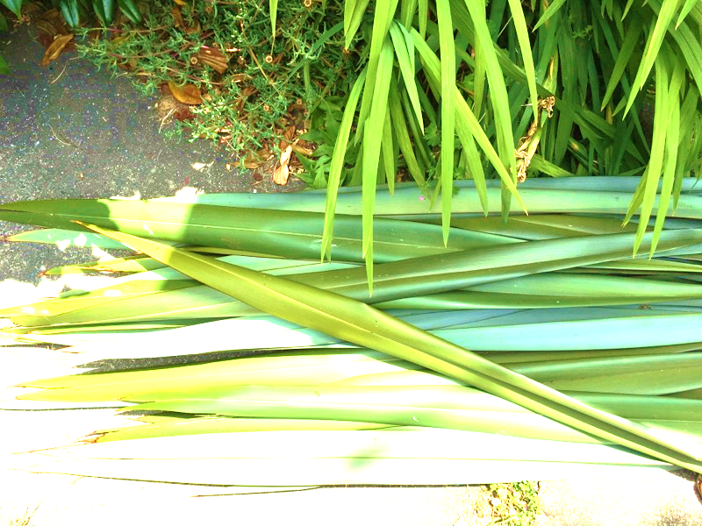
Stepping Stones 2017 Miss Brightwell

Tena koe nau mai haere mai
Welcome to stepping stones. I will be teaching stepping stones students in a 2 hour slot on Tuesdays. We will be creating a range of Maori items during the year. 8 level 2 credits in raranga (maori weaving) will be on offer. The credits will be assessed using an online blog where photographs and blogging will be used as assessment evidence.
The aim of my lessons is to give students:
- understanding of the tikanga associated with harakeke.
- Insight into the legends, history, uses and importance of harakeke to Maori.
- Develop skills to care for harvest and create items from harakeke using traditional techniques.

Term 1
Harakeke care and tikanga, harvesting and preparation
Basic harakeke items: placemat, flowers, konae
Poi
Term 2
Preparing harakeke to weave a kete kumara
Term 3
Preparing harakeke to weave a kete timata
Term 4
Resubmissions
Personal project: kite, kono, back pack

Standards taught in this course by me are internals:
- US 7869 Prepare harakeke for a kete L2 2 credits
- US 7907 Make a kete kumara L2 2 credits
- US 7882 Make a kete timata L2 4 credits

Examples of the skills we will learn and things we will make:
Term 1
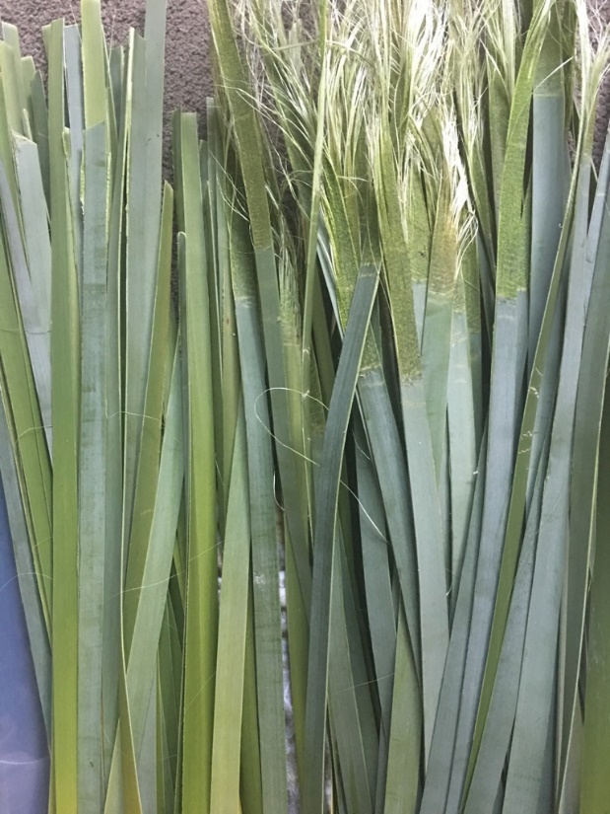
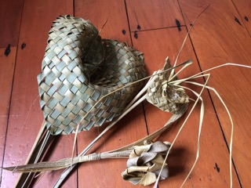

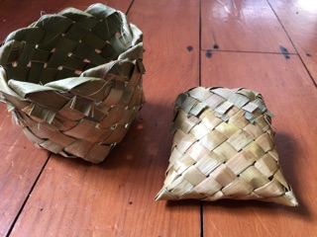

Term 2:
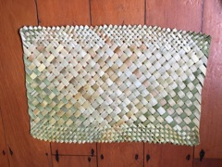
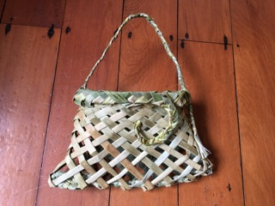

Term 3
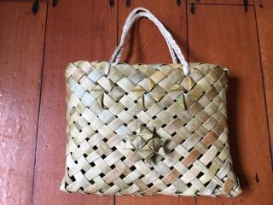

Term 4
A personal project of your own:
